**HAMILTON-WENTWORTH CHAPTER OF**

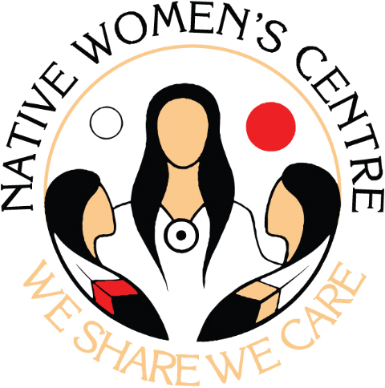

**NATIVE WOMEN INCORPORATED**

**MEMBERSHIP FORM**

**2025-2026**

Thank you for your inquiry regarding membership to the Hamilton-Wentworth Chapter of Native Women Incorporated. Our membership is as follows:

**FULL MEMBER:** *An Indigenous woman over the age of 18 years or spouse of a man of Indigenous ancestry.*

*OR*

**ASSOCIATE MEMBER:**  *All others who are interested who do not meet the FULL MEMBER requirements. This includes men, organizations, non-Indigenous*

*women, youth, etc.* Associate Members are **not** eligible to vote.

Members Name:

Mailing Address:

Phone Number:

Email Address:

Membership Type: □ Full □ Associate

Indigenous Indentification: □First Nation □Métis □Inuit □Non-Status □Non-Indigenous

Cost of Membership: $5.00 for Full and Associate Member

Please send completed membership form along with membership fee to:

Native Women’s Centre

1900 King St. E

PO Box 69036

Hamilton, ON, L8K 6R4

FOR OFFICE USE ONLY:

Date Received: Membership Type: □ FULL □ ASSOCIATE

Added to Membership list by: Membership Fee Paid: □ Yes □ No

Membership Expiry Date: ___